**Understanding Objects in JavaScript**

**Key Concepts of JavaScript Objects**

1. **Definition**: An object in JavaScript is a collection of key-value pairs where keys are strings (or Symbols) and values can be of any type (including other objects, functions, and primitive values).
2. **Properties and Methods**:
   * **Properties**: Attributes or data held by an object.
   * **Methods**: Functions that are stored as properties in an object.
3. **Creating Objects**: Objects can be created in multiple ways, including using ***object literals, the Object constructor, or through classes.***
4. **Manipulating Objects**: JavaScript provides various ways to interact with objects, such as accessing, adding, modifying, and deleting properties.

Object Can be created and used by 4 Ways:

1. Object Literals
2. Object constructor
3. Object create method
4. Using Class
   * + 1 and 4 is the most commonly used

#### **Object Literals –**

#### **The most common way to create an object in JavaScript is by using object literals.**

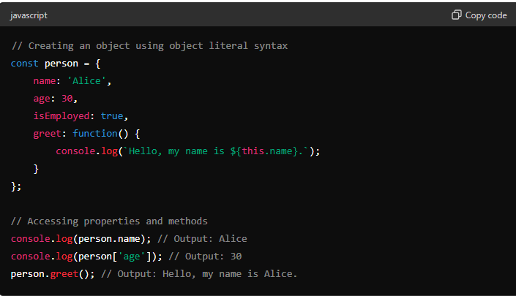

#### **Object Constructor –**

#### **You can also create objects using the Object constructor.**

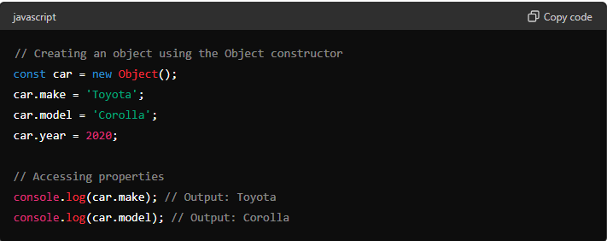

#### **Using the Object.create Method**

#### **- The Object.create method allows you to create a new object with a specified prototype object and properties.**

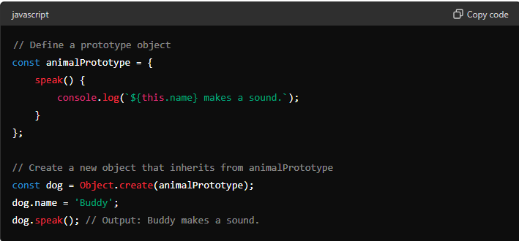

#### **Using Classes**

#### **- Classes provide a more structured way to create and manage objects, especially when dealing with complex objects and inheritance.**

